Identifying Liquids in which Seeds Grow Best
Science Fair
Kristen Potluk
Denis Gagnon
Feb 13, 2012

Problem: Which liquid do seeds grow best with under controlled conditions? Using different liquids I will test which of the selected liquids have the best growing sunflower seed.

Variables:
Controlled:
Type of light (Fluorescent bulb) | 8 ounces of liquid | Amount of days growing (6 weeks)
Type of soil (______) | Same pot (Dixie cup) | Watered Monday, Thursday and Saturday
Sunflower seed (same seed pack) | Depth of planted seed (2 cm) | Record height every day at 4pm
Amount of dirt (¼ cup) | Amount of seeds using same liquid (3) | Photo of plants at 4pm
Environment (same fish tank) | Temperature (35 Celsius) | Temp. of liquid (refrigerated)

Manipulated

Type of liquid | Vinegar
Tap water | Milk
Bottled water | Tap water w/ dissolved fertilizer (1tsp per 3 ounces)
Orange juice (pulp-free Tropicana)
Sugar water (1tsp per 3 ounces)

Responding

Height of plant
Color of plant (pale green/dark green/brown)
Physical appearance (health wise)

Hypothesis
The water with fertilizer dissolved will grow the best because it has nutrients necessary for healthy plant growth including Nitrogen which is a part in all proteins found in cells, enzymes and metabolic processes involved in energy transfer (NADP), its part chlorophyll (green pigment necessary for photosynthesis), helps with growth, increased seed and fruit production. Phosphorous is also necessary for photosynthesis, involved in formation of oils, sugars and starches, and rapid growth and encourages blooming and root growth. Potassium most absorbed element except nitrogen, builds proteins, photosynthesis (ATP/NADP), fruit quality and reduction of disease. Calcium is part of the cell wall structure and strength of plant and counter act the effects of alkali salts and organic acids within plant. Magnesium makes up part of the green pigment, chlorophyll and it helps activate enzymes. Sulfur is used in proteins in the plant, activity of enzymes and vitamins, chlorophyll formation, and vigorous plant growth. With all these beneficial elements found in fertilizer, the plant will grow to be the tallest, healthiest, strongest and greenest.

Materials
- 18 sunflower seeds
- 8 ounces of tap water
- 8 ounces bottled water (Aquafina)
- 8 ounces orange juice (Pulp free Tropicana)
- 8 ounces vinegar
- 8 ounces milk (2%)
- 8 ounces sugar water (1tsp water per 3 ounces)
- 8 ounces tap water w/ dissolved fertilizer (1tsp per 3 ounces)
- 18 Dixie cups
- Fish tank
- Fluorescent light bulb
- Ruler
- ¼ cup Soil (per Dixie cup)
- Camera

Procedure
- Put ¼ cup of dirt in 18 Dixie cups
- Plant sun flower seeds 2 cm deep in each cup
- Place cups in fish tank under fluorescent bulb in a 3x6 array
- Give 8 ounces liquid (refrigerated) to sunflowers
- 3 with 8 ounces tap water
- 3 with 8 ounces bottled water (Aquafina)
- 3 with 8 ounces orange juice (Pulp free Tropicana)
- 3 with 8 ounces vinegar
- 3 with 8 ounces milk (2%)
- 3 with 8 ounces sugar water (1tsp per 3 ounces)
- 3 with 8 ounces tap water w/ dissolved fertilizer (1tsp per 3 ounces)
(Side note: each tsp./per 3 ounces water will be mixed prior to the liquid being watered on sunflowers; JUST BEFORE WATERING)
- Take photo (starting at day 0) @ 4pm
- Record height (starting at day 0) @4pm
- Repeat steps 4, 5 and 6 on Monday, Thursday and Saturday @ 4pm for 6 weeks
Analysis

Tap water | Bottled water (Aquafina) | Orange juice (pulp free Tropicana) | Milk (2%) | Vinegar | Sugar water (1tsp/3 ounces) | Tap water w/ fertilizer (1tsp/3ounces)
Mon.  0 cm  0 cm  0 cm  Thurs.  0 cm  0 cm  0 cm  Sat.  1 cm  1.2 cm  1.1cm | Mon.  0 cm  0 cm  0 cm  Thurs.  0 cm  0 cm  0 cm  Sat.  1 cm  1 cm  1.2 cm | Mon.  0 cm  0 cm  0 cm  Thurs.  0 cm  0 cm  0 cm  Sat.  0 cm  0 cm  0 cm | Mon.  0 cm  0 cm  0 cm  Thurs.  0 cm  0 cm  0 cm  Sat.  0 cm  0 cm  0 cm | Mon.  0 cm  0 cm  0 cm  Thurs.  0 cm  0 cm  0 cm  Sat.  0 cm  0 cm  0 cm | Mon.  0 cm  0 cm  0 cm  Thurs.  0 cm  0 cm  0 cm  Sat.  1 cm  1.1cm  0.9 cm | Mon.  0 cm  0 cm  0 cm  Thurs.  0 cm  0 cm  0.4 cm  Sat.  1.5 cm  1.0 cm  1.3 cm
Mon.  1.7cm  1.7 cm  1.8 cm  Thurs.  2.3 cm  2.4cm  2.3cm  Sat.  2.7 cm  2.5 cm  2.7 cm | Mon.  1.6 cm  1.7 cm  1.5 cm  Thurs.  2.4 cm  2.5 cm  2.3 cm  Sat.  2.7 cm  2.6 cm  2.7 cm | Mon.  1 cm  1.1 cm  1 cm  Thurs.  1 cm  1.2 cm  1.3 cm  Sat.  1.5 cm  1.5 cm  1.5 cm | Mon.  0.5cm  0.4 cm  0.5 cm  Thurs. 1.2cm  1.0 cm  1.1 cm  Sat.  1.7cm  1.3 cm  1.5 cm | Mon.  0.3cm  0.5 cm  0.4 cm  Thurs. 0.8cm  0.9 cm  0.7 cm  Sat.  1 cm  1.2 cm  1.2 cm | Mon.  1.3 cm  1.3 cm  1.4 cm  Thurs.  1.7 cm  1.6 cm  1.8 cm  Sat.  2.2 cm  2.2 cm  2.3 cm | Mon.  1.9 cm  2.0 cm  2.1 cm  Thurs.  2.4 cm  2.3 cm  2.5 cm  Sat.  2.9 cm  2.8 cm  2.9 cm
Mon.  3 cm  3.1 cm  3.1 cm  Thurs.  3.4 cm  3.4 cm  3.5 cm  Sat.  4 cm  4.1 cm  4 cm | Mon.  2.9 cm  2.5 cm  2.7 cm  Thurs.  3.2 cm  3.2 cm  3.3 cm  Sat.  3.8 cm  3.7cm  3.5cm | Mon.  2.3 cm  2.2 cm  2.3 cm  Thurs.  2.5 cm  2.5 cm  2.4 cm  Sat.  3.0 cm  2.7 cm  2.9 cm | Mon.  2.1 cm  2.2 cm  2.0 cm  Thurs.  2.4 cm  2.3 cm  2.3 cm  Sat.  2.7 cm  2.5 cm  2.5 cm | Mon.  1.3 cm  1.4 cm  1.3 cm  Thurs.  1.5 cm  1.6 cm  1.5 cm  Sat.  1.8 cm  1.7 cm  1.7 cm | Mon.  2.5 cm  2.4 cm  2.5 cm  Thurs.  2.9 cm  3.0 cm  2.8 cm  Sat.  3.2 cm  3.3 cm  3.1 cm | Mon.  3.2 cm  3.3 cm  3.2 cm  Thurs.  3.9 cm  3.7 cm  3.5 cm  Sat.  4.3 cm  4.3cm  4.4cm
Mon.  4.3 cm  4.3 cm  4.2 cm  Thurs.  4.9 cm  4.7 cm  4.7 cm  Sat.  5.2 cm  5.3 cm  5.2 cm | Mon.  4.1 cm  4.2 cm  3.9 cm  Thurs.  4.8 cm  4.5 cm  4.7 cm  Sat.  5.2 cm  5.3 cm  5.1 cm | Mon.  3.2 cm  3.1 cm  3.3 cm  Thurs.  3.5 cm  3.6 cm  3.5 cm  Sat.  3.9cm  3.8 cm  3.9 cm | Mon.  3 cm  2.8 cm  2.9 cm  Thurs. 3.3cm  3.2 cm  3.3 cm  Sat.  3.7 cm  3.6 cm  3.8 cm | Mon.  2 cm  1.9 cm  1.9 cm  Thurs.  2.4 cm  2.5 cm  2.2 cm  Sat.  2.7cm  2.6 cm  2.5 cm | Mon.  3.4 cm  3.5 cm  3.5 cm  Thurs. 3.9cm  4.0 cm  3.8 cm  Sat.  4.3 cm  4.2 cm  4.1 cm | Mon.  4.8cm  4.8 cm  4.6 cm  Thurs.  5.2 cm  5.3 cm  5.3 cm  Sat.  5.7 cm  5.7 cm  5.6 cm
Mon.  5.4 cm  5.5 cm  5.6 cm  Thurs.  5.7 cm  5.8 cm  5.8 cm  Sat.  6 cm  6.1 cm  6.1 cm | Mon.  5.5 cm  5.3 cm  5.4 cm  Thurs.  5.8 cm  5.8 cm  5.7 cm  Sat.  6.1 cm  6.2 cm  6.0 cm | Mon.  4.2 cm  4.3 cm  4.2 cm  Thurs.  4.5 cm  4.5 cm  4.6 cm  Sat.  4.8 cm  4.9 cm  4.8 cm | Mon.  4.0 cm  4.2 cm  4.1 cm  Thurs.  4.2 cm  4.2 cm  4.3 cm  Sat.  4.6 cm  4.5 cm  4.5 cm | Mon.  3.1 cm  3.2 cm  3.0 cm  Thurs.  3.4 cm  3.2 cm  3.3 cm  Sat.  3.4 cm  3.5 cm  3.5 cm | Mon.  4.5 cm  4.6 cm  4.5 cm  Thurs.  4.8 cm  4.9 cm  4.8 cm  Sat.  5cm  5.1 cm  5.2 cm | Mon.  6 cm  6.1 cm  6.2 cm  Thurs.  6.3 cm  6.4 cm  6.3 cm  Sat.  6.8 cm  6.7 cm  6.6 cm
Mon.  6.3 cm  6.3 cm  6.2 cm  Thurs.  6.5 cm  6.5 cm  6.6 cm  Sat.  6.9 cm  7.0 cm  6.9 cm | Mon.  6.3 cm  6.3 cm  6.2 cm  Thurs.  6.6 cm  6.5 cm  6.4 cm  Sat.  6.8 cm  6.9 cm  6.6 cm | Mon.  5 cm  5.2 cm  5.1 cm  Thurs.  5.3 cm  5.3 cm  5.4 cm  Sat.  5.5 cm  5.5 cm  5.6 cm | Mon.  4.8 cm  4.9 cm  4.7 cm  Thurs.  5.0 cm  5.2 cm  5.3 cm  Sat.  5.0 cm  5.3 cm  5.2 cm | Mon.  3.6 cm  3.7 cm  3.6 cm  Thurs.  3.7 cm  3.8 cm  3.7 cm  Sat.  3.9 cm  3.9 cm  3.9 cm | Mon.  5.2 cm  5.3 cm  5.4 cm  Thurs.  5.4 cm  5.5 cm  5.5 cm  Sat.  5.8 cm  5.9 cm  5.8 cm | Mon.  6.9 cm  6.9 cm  7.0 cm  Thurs.  7.2 cm  7.3 cm  7.3 cm  Sat.  7.4 cm  7.5 cm  7.5 cm

Tap water | Bottled water | Orange juice | Milk | Vinegar | Sugar water | Fertilized water
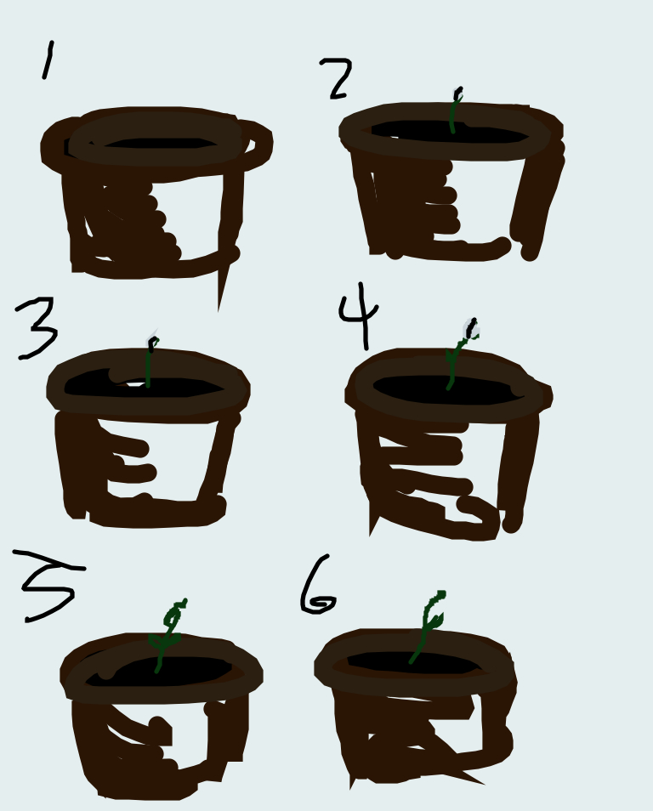 | 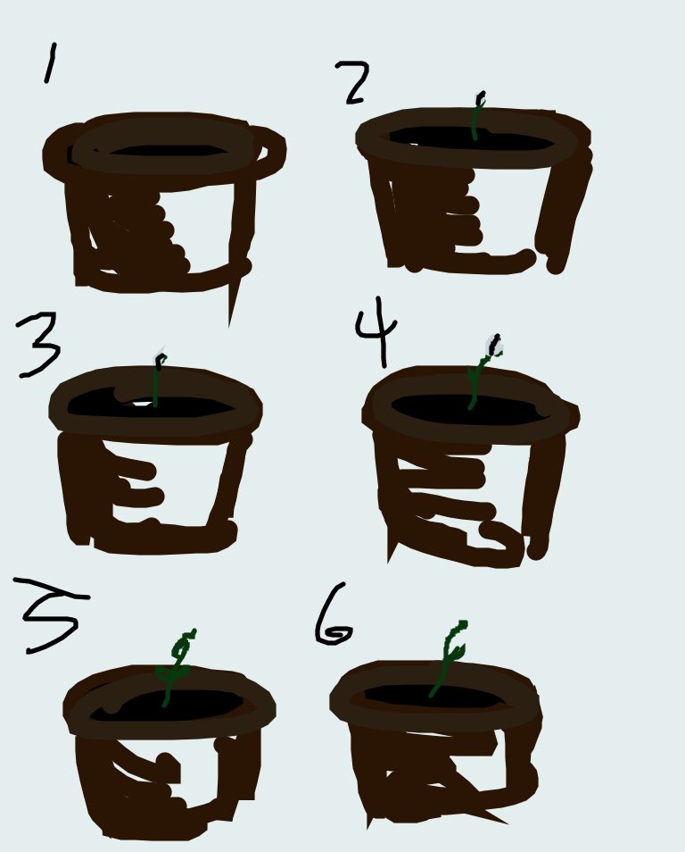 | 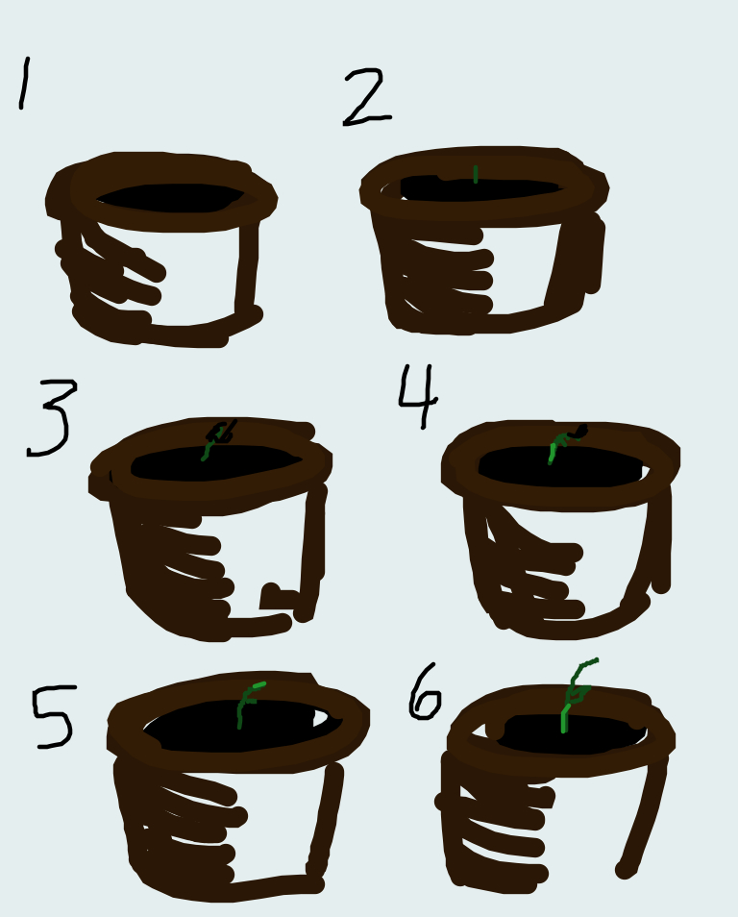 | 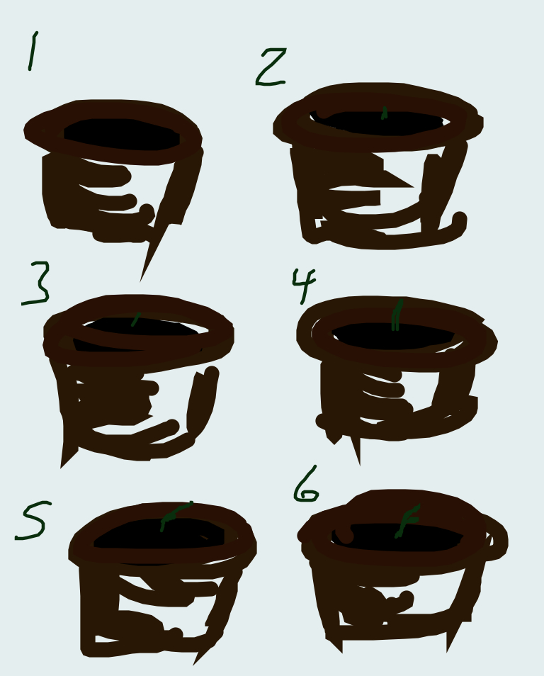 |  |  | 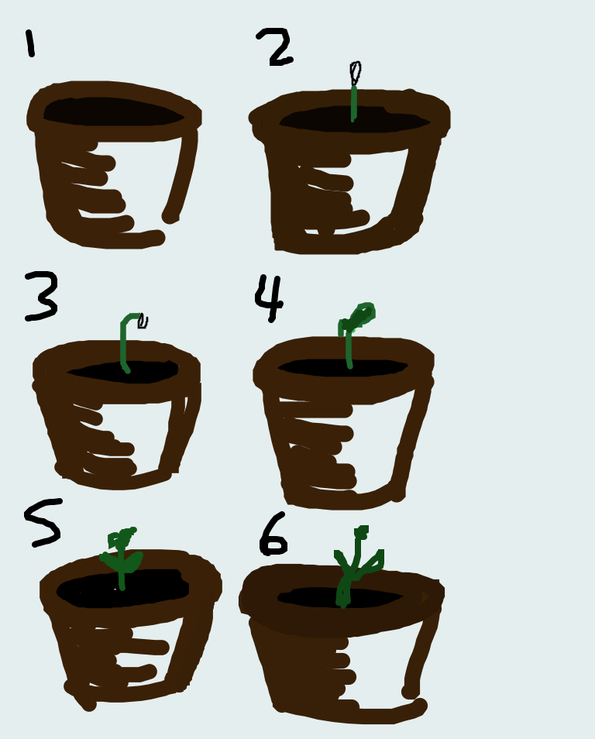

Height per week/Friday of Each Liquid

Conclusion: I conclude that water with the dissolved fertilizer grew the plants best in height, color (for photosynthesis), and healthy disposition. All the additional nutrients from the fertilizer helped the plant take in all the necessary elements involved in healthy and fruitful plant growth. In the end it was a rich blue-green vibrant color, a strong thicker stock, and an entire centimeter over the other plants watered with the other liquids. My hypothesis was correct in the fact that the fertilizer gave the sunflowers an additional boost in nutrients such as nitrogen, phosphorous, potassium, calcium and sulfur.

