Student Worksheet LSM 7.3 L
Theoretical ATP Yield from Aerobic Respiration
In the empty boxes on the diagram, fill in the numbers of molecules produced from one glucose molecule at each step of aerobic cellular respiration.
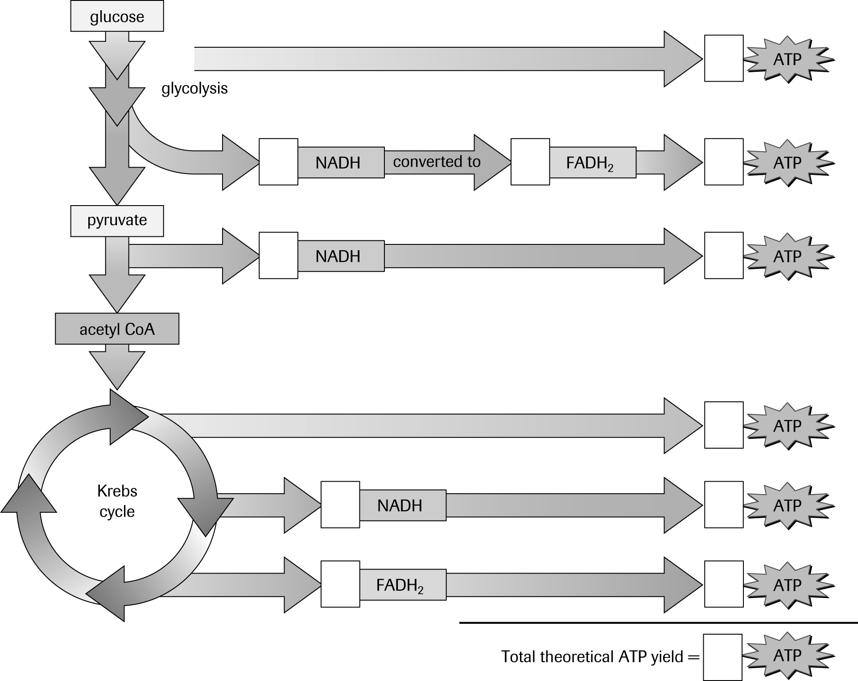
Theoretical ATP yield from the aerobic respiration of one glucose molecule

