Summary of Photosynthesis

- Complete the chart below to identify basic steps in photosynthesis.

Photosynthesis
Energy | Reactions | Location
 | Water splits, forms oxygen
 | Chemiosmosis
Energy from the light-dependent reactions is used

- Using the labels provided, label the structures of the chloroplast and indicate where the processes occur.
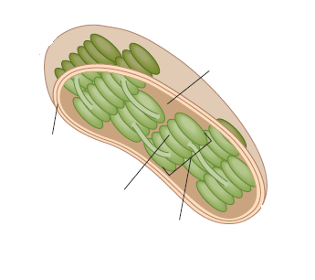
Structures | Processes
thylakoid | light-dependent reactions
stroma | chemiosmosis
inner and outer membranes | Calvin-Benson cycle
granum

The following diagram depicts the transfer of an electron from compound A to compound B. Use this diagram to answer Question 1.
Oxidation Reduction

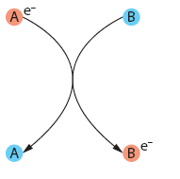

1. a) Is compound A undergoing oxidation or reduction? Why or why not?

___________________________________________________________________________
___________________________________________________________________________
___________________________________________________________________________

b) Is compound B undergoing oxidation or reduction? Why or why not?
___________________________________________________________________________
___________________________________________________________________________
___________________________________________________________________________

2. Indicate whether each of the statements is true or false. If it is false, rewrite the statement to make it true.
TRUE/  FALSE | a) An atom or molecule that loses an electron is said to be oxidized.  _________________________________________________________________
TRUE/  FALSE | b) A molecule that donates an electron to another molecule is called an oxidizing agent.  _________________________________________________________________
TRUE/  FALSE | c) Compounds contain more energy in their oxidized form.  _________________________________________________________________
TRUE/  FALSE | d) Oxidations and reductions occur independently of each other and are not linked in any way.  _________________________________________________________________

